5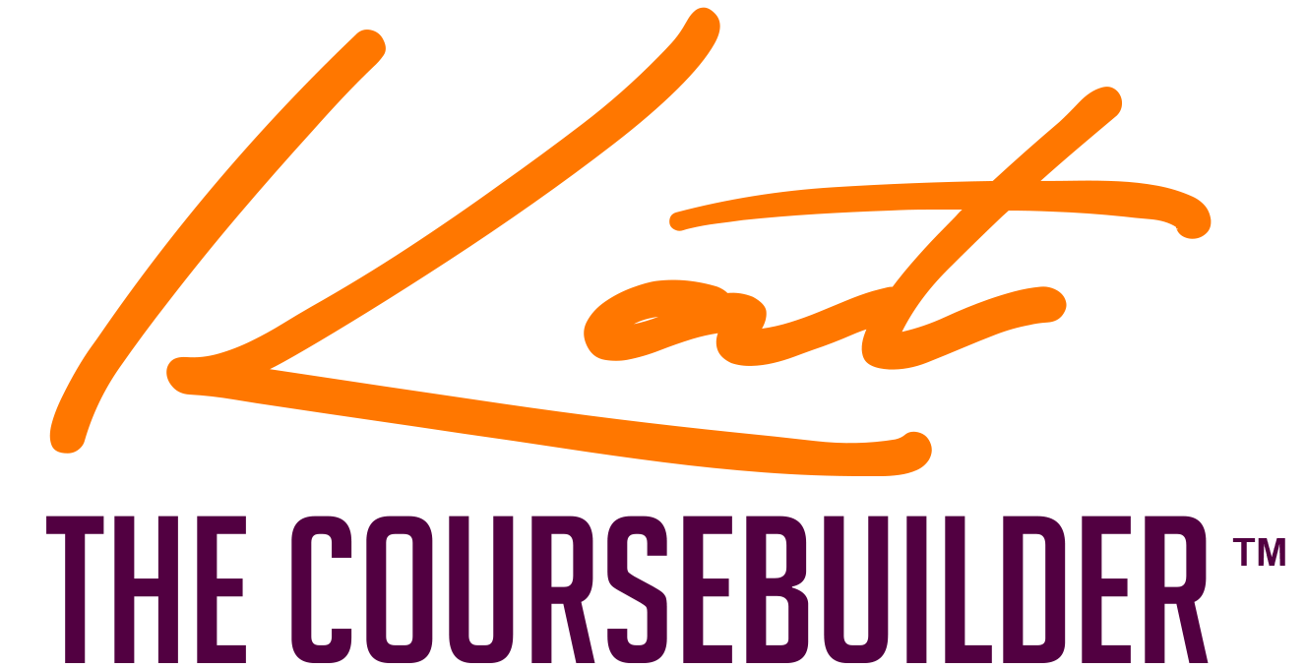

Top 12 Elements for A Course That Sells and Sizzles

Does your course have these elements?

No: | Element | Yes  No | Notes
1 | Course Name
2 | Course Avatar
3 | Course Objectives
4 | Course Prerequisite
5 | Course Prework
6 | Course Modules
7 | Course Lessons
8 | Course Modality
9 | Course Activities
10 | Course Navigation
11 | Course Talking points
12 | Course Production Style

